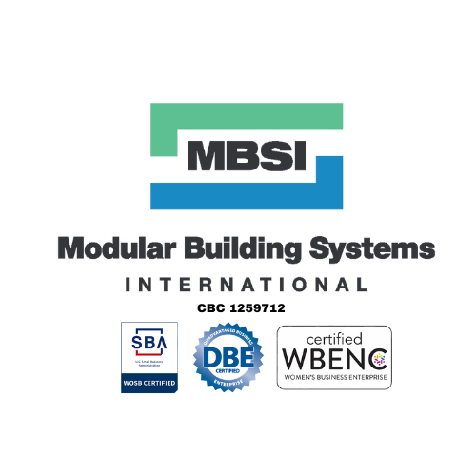

MBSI Capabilities Statement
Modular Building Systems International | Certified WBENC • DBE • SBA
CBC FL 1259712 | CBC TN 74993

Company Overview
With over 25 years of experience, Modular Building Systems International (MBSI) is a trusted provider of Class A modular building solutions for education, healthcare, government, hospitality, and construction sectors. We specialize in delivering high-performance, turnkey buildings that meet rigorous quality and compliance standards while reducing project timelines and costs.

Proven Quality & Standards
Our lease-ready Class A units are built with above-industry-standard features, including:
- Double subfloors for enhanced structural integrity
- Large windows with sills for increased natural light and visual appeal
- Upgraded lighting, flooring, and interior finishes for improved comfort and functionality
- Wind-load resistance up to 160 mph for maximum durability and safety

Core Capabilities
We manage the complete lifecycle of modular building projects, from initial concept to final occupancy, ensuring every phase is executed with precision.
- Custom Design & Planning – Tailored solutions that align with client specifications and operational requirements
- Permitting & Code Compliance – Expert navigation of regulatory requirements across multiple states
- Site Work & Utility Infrastructure – Comprehensive site preparation and utility integration
- Controlled Manufacturing – Indoor production to eliminate weather delays and maintain strict quality control
- Logistics, Delivery & Setup – Coordinated transport, secure placement, and on-time delivery
- On-Site Finishing – Professional final detailing for immediate use

Industries Served
- Education: Classrooms, administrative offices, dormitories
- Healthcare: Clinics, laboratories, mobile medical units
- Government: Field offices, emergency facilities, military applications
- Hospitality: Hotels, cabins, staff housing
- Construction: Site offices, workforce housing, storage units

Performance Advantages
- Build Time: 30–50% faster than conventional construction
- Cost Efficiency: Up to 20% savings over traditional methods
- Project Range: 300 sq. ft. to 30,000+ sq. ft.
- Proven Track Record: Trusted by leading contractors and state agencies
- Rapid Response: Quickly respond to your inquiries

